# Array VS Recursive

Data Testing:

From the result of date testing, we find that:

1.The time consumed by array way is steady and short with the increase of the length of the Fibonacci sequence;

2.The time consumed by recursive way is increasing with the increase of the length of the Fibonacci sequence, especially when the length is more than 30;

3.When the length of the Fibonacci sequence is small enough, recursive way takes less time, but this advantage disappear once the length is a little bigger, for example, more than 20.

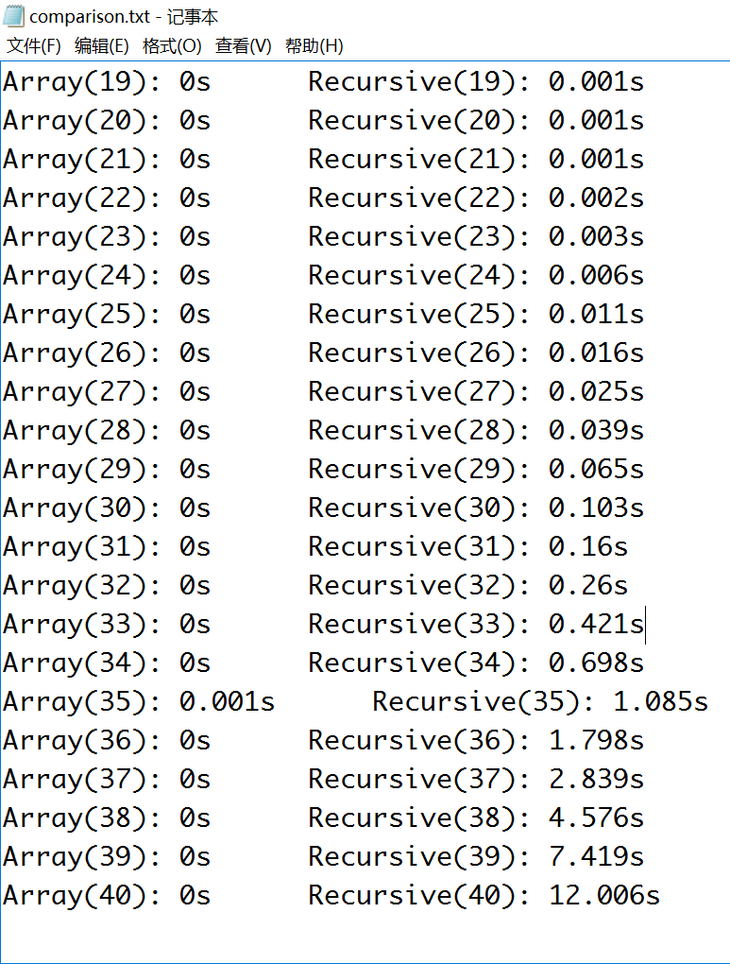

Theoretical Analysis:

The reason why array way is usually more efficient than recursive way is that:

When we use an array to generate a Fibonacci sequence, we calculate the element one by one, and for each element we just do this once. However, if we use recursive function to implement this, we have to calculate the elements repeatedly, which is far more time-consuming. The time consumed by recursive function increases exponentially with the increase of the index n.

**The following fitted curve displays the time consumed by recursive function to generate a Fibonacci sequence that has index elements:**

